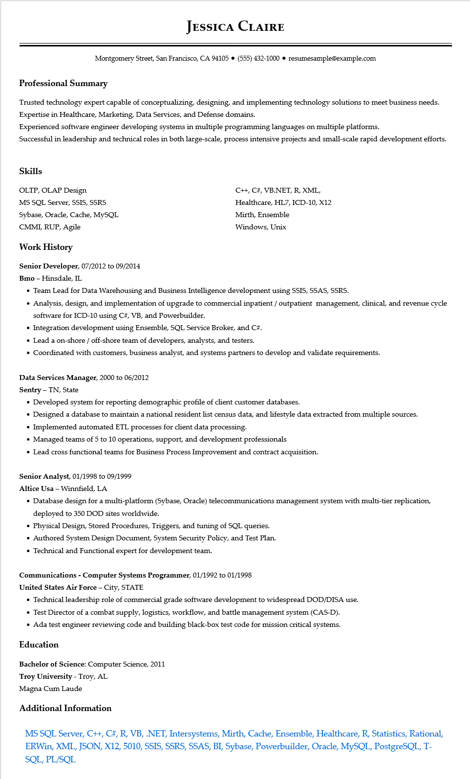
JESSICA CLAIRE
Montgomery Street, San Francisco, CA 94105⚫ (555) 432-1000⚫ resumesample@example.com
Professional Summary
Trusted technology expert capable of conceptualizing, designing, and implementing technology solutions to meet business needs. Expertise in Healthcare, Marketing, Data Services, and Defense domains.
Experienced software engineer developing systems in multiple programming languages on multiple platforms.
Successful in leadership and technical roles in both large-scale, process intensive projects and small-scale rapid development efforts.
Skills
OLTP, OLAP Design
MS SQL Server, SSIS, SSRS
Sybase, Oracle, Cache, MySQL
CMMI, RUP, Agile
Work History
Senior Developer, 07/2012 to 09/2014
Bmo - Hinsdale, IL
C++, C#, VB.NET, R, XML, Healthcare, HL7, ICD-10, X12
Mirth, Ensemble
Windows, Unix
• Team Lead for Data Warehousing and Business Intelligence development using SSIS, SSAS, SSRS.
• Analysis, design, and implementation of upgrade to commercial inpatient / outpatient management, clinical, and revenue cycle software for ICD-10 using C#, VB, and Powerbuilder.
• Integration development using Ensemble, SQL Service Broker, and C#.
• Lead a on-shore / off-shore team of developers, analysts, and testers.
• Coordinated with customers, business analyst, and systems partners to develop and validate requirements.
Data Services Manager, 2000 to 06/2012
Sentry - TN, State
• Developed system for reporting demographic profile of client customer databases.
• Designed a database to maintain a national resident list census data, and lifestyle data extracted from multiple sources.
• Implemented automated ETL processes for client data processing.
• Managed teams of 5 to 10 operations, support, and development professionals
• Lead cross functional teams for Business Process Improvement and contract acquisition.
Senior Analyst, 01/1998 to 09/1999
Altice Usa - Winnfield, LA
• Database design for a multi-platform (Sybase, Oracle) telecommunications management system with multi-tier replication, deployed to 350 DOD sites worldwide.
• Physical Design, Stored Procedures, Triggers, and tuning of SQL queries.
• Authored System Design Document, System Security Policy, and Test Plan.
• Technical and Functional expert for development team.
Communications - Computer Systems Programmer, 01/1992 to 01/1998
United States Air Force - City, STATE
• Technical leadership role of commercial grade software development to widespread DOD/DISA use.
• Test Director of a combat supply, logistics, workflow, and battle management system (CAS-D).
• Ada test engineer reviewing code and building black-box test code for mission critical systems.
Education
Bachelor of Science: Computer Science, 2011
Troy University - Troy, AL
Magna Cum Laude
Additional Information
MS SQL Server, C++, C#, R, VB, .NET, Intersystems, Mirth, Cache, Ensemble, Healthcare, R, Statistics, Rational, ERWin, XML, JSON, X12, 5010, SSIS, SSRS, SSAS, BI, Sybase, Powerbuilder, Oracle, MySQL, PostgreSQL, T- SQL, PL/SQL

